**CSE1003 – Digital Logic & Design - ELA (LTSpice), Winter Semester 2020-2021**

**LAB FAT EXAM – Simulation Results**

**By: Jonathan Rufus Samuel (20BCT0332) Date: 21.6.2021**

__________________________________________________________________________________

**Q1) Write R code to compute mean, median, mode, variance, standard deviation and coefficient of variation for the following frequency distribution:**

|  |  |  |  |  |  |  |  |
| --- | --- | --- | --- | --- | --- | --- | --- |
| **Expenditure** | **20-30** | **30-40** | **40-50** | **50-60** | **60-70** | **70-80** | **80-90** |
| **No. of families** | **3** | **61** | **132** | **153** | **140** | **51** | **2** |

**Procedure & Result:**

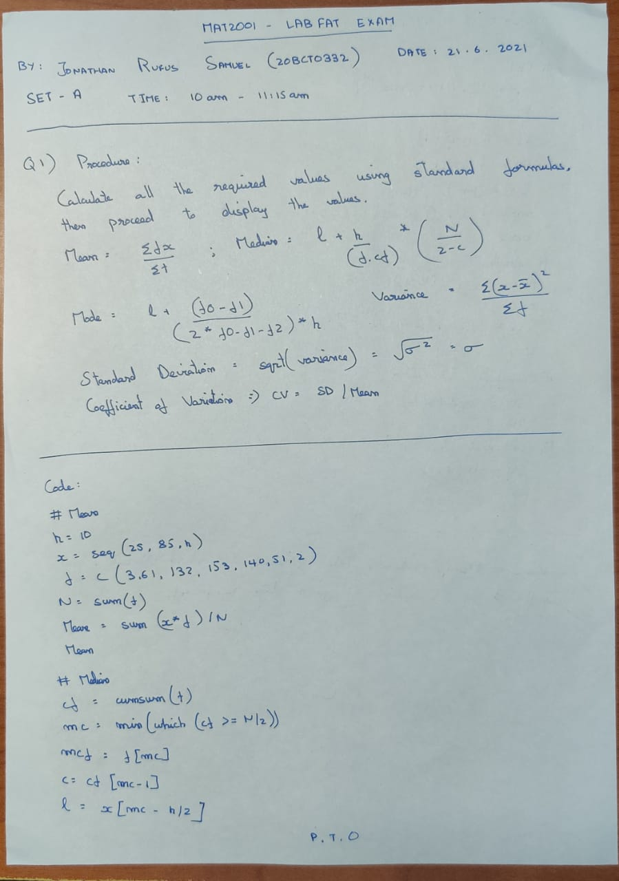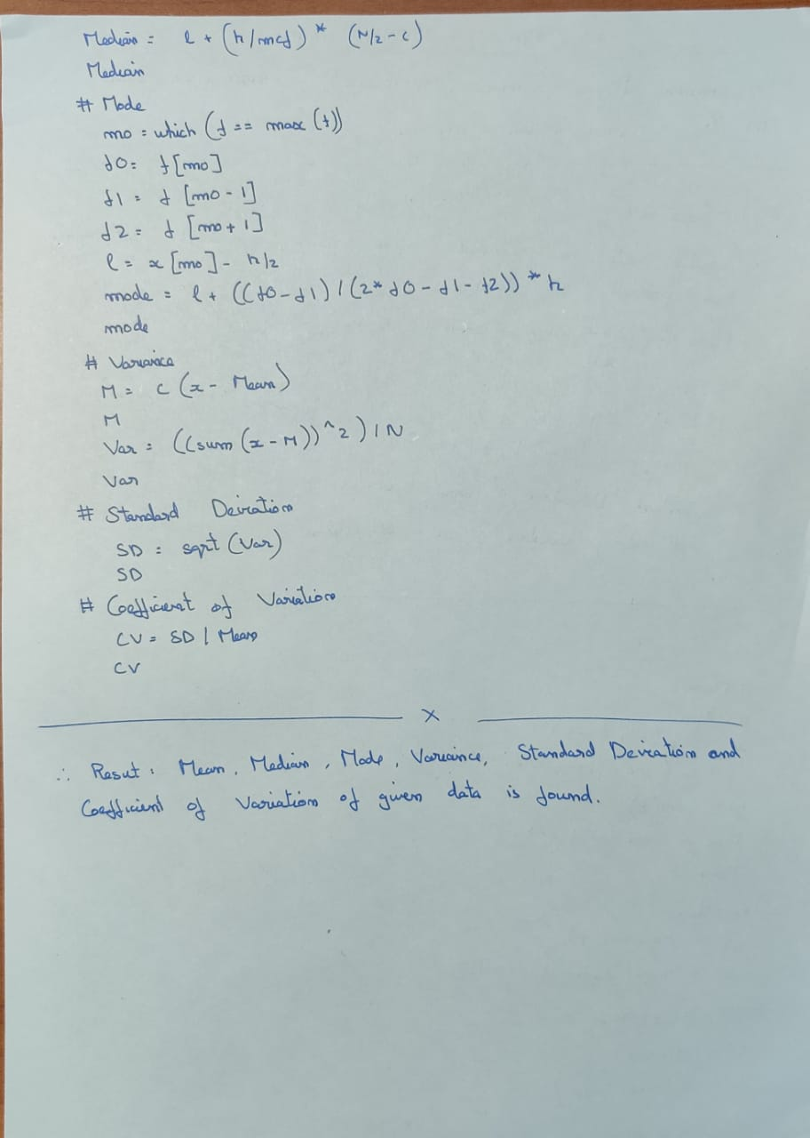

**Output:**

A: Code is as follows:

#mean

h = 10

x = seq(25,85,h)

f = c(3,61,132,153,140,51,2)

N = sum(f)

Mean = sum(x*f)/N

Mean

#median

cf = cumsum(f)

mc = min(which(cf>=N/2))

mcf=f[mc]

c=cf[mc-1]

l=x[mc]-h/2

Median=l+(h/mcf)*((N/2-c))

Median

#mode

mo=which(f==max(f))

f0=f[mo]

f1=f[mo-1]

f2=f[mo+1]

l=x[mo]-h/2

mode = l+((f0-f1)/(2*f0-f1-f2))*h

mode

#Variance

M = c(x-Mean)

M

Var = ((sum(x-M))^2)/N

Var

#Standard Deviation

SD = sqrt(Var)

SD

#Co-efficient of Variation

CV = SD/Mean

CV

**Output (via Command Window):**

> #mean

> h = 10

> x = seq(25,85,h)

> f = c(3,61,132,153,140,51,2)

> N = sum(f)

> Mean = sum(x*f)/N

> Mean

[1] 54.72325

> #median

> cf = cumsum(f)

> mc = min(which(cf>=N/2))

> mcf=f[mc]

> c=cf[mc-1]

> l=x[mc]-h/2

> Median=l+(h/mcf)*((N/2-c))

> Median

[1] 54.90196

> #mode

> mo=which(f==max(f))

> f0=f[mo]

> f1=f[mo-1]

> f2=f[mo+1]

> l=x[mo]-h/2

> mode = l+((f0-f1)/(2*f0-f1-f2))*h

> mode

[1] 56.17647

> #Variance

> M = c(x-Mean)

> M

[1] -29.7232472 -19.7232472 -9.7232472 0.2767528 10.2767528 20.2767528

[7] 30.2767528

> Var = ((sum(x-M))^2)/N

> Var

[1] 270.7326

> #Standard Deviation

> SD = sqrt(Var)

> SD

[1] 16.45395

> #Co-efficient of Variation

> CV = SD/Mean

> CV

[1] 0.3006757

**Implementation on R Studio Code (via Command Window):**

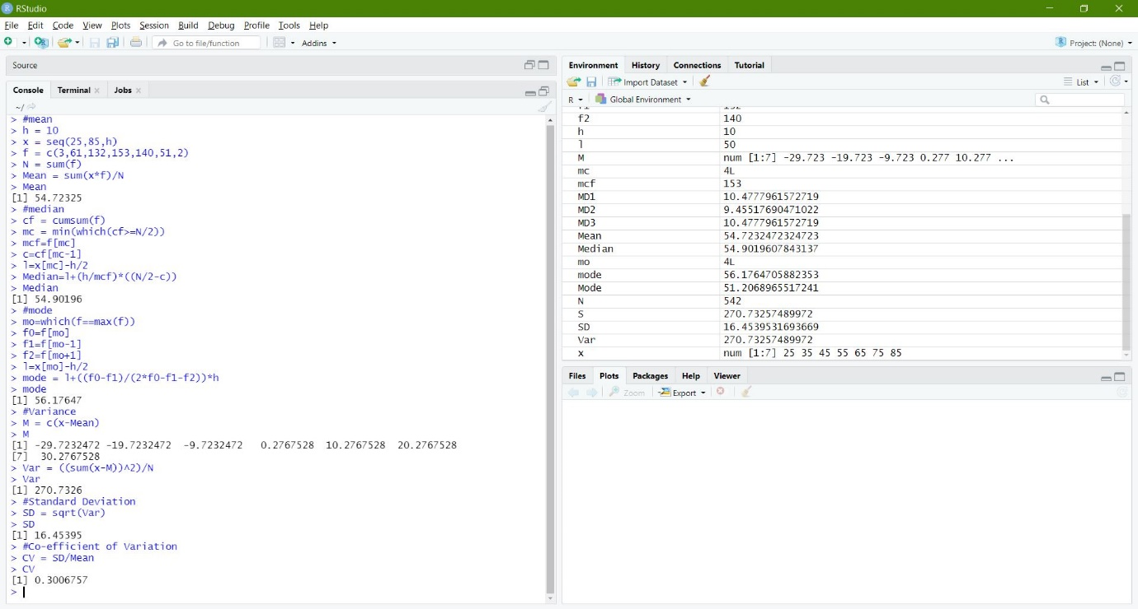

**Global Variables:**

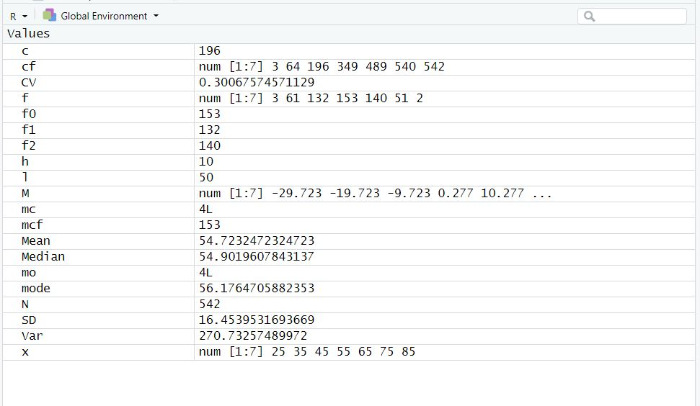

**Q2) A completely randomized design experiment with 10 plots and 3 treatments (A,B and C) gave the following results:**

|  |  |  |  |  |
| --- | --- | --- | --- | --- |
| **A:** | **5** | **7** | **3** | **1** |
| **B:** | **4** | **4** | **7** |  |
| **C:** | **3** | **5** | **1** |  |

**Write down the R programming code to analyse the results for treatment effects with 95% levels of confidence.**

**Procedure & Result:**

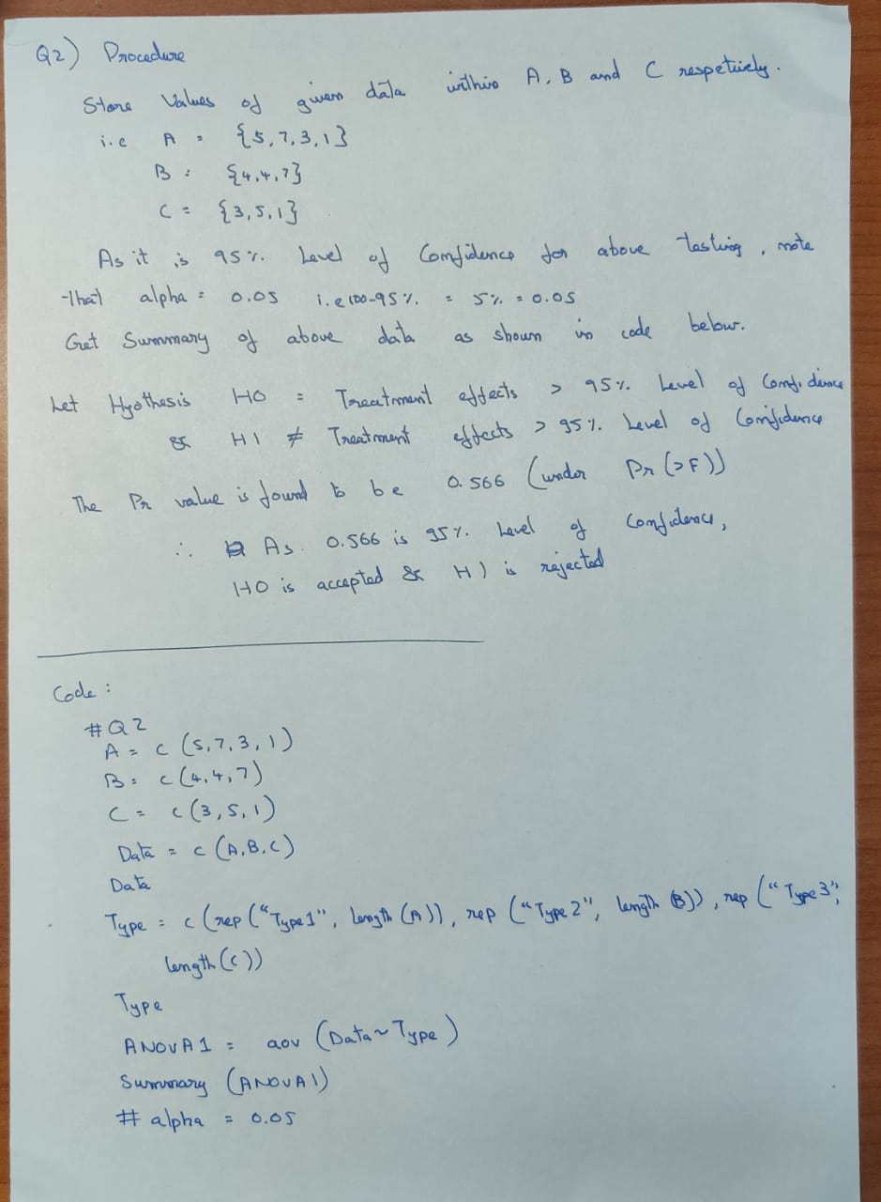

**Output:**

A: Code is as follows:

#Q2

A = c(5,7,3,1) #nA = 4

B = c(4,4,7) #nB = 3

C = c(3,5,1) #nC = 3

Data=c(A,B,C)

Data

Type=c(rep("Type1",length(A)),rep("Type2",length(B)),rep("Type3",length(C)))

Type

ANOVA1=aov(Data~Type)

summary(ANOVA1)

#alpha = 0.05

**Output (via Command Window):**

> #Q2

> A = c(5,7,3,1) #nA = 4

> B = c(4,4,7) #nB = 3

> C = c(3,5,1) #nC = 3

> Data=c(A,B,C)

> Data

[1] 5 7 3 1 4 4 7 3 5 1

> Type=c(rep("Type1",length(A)),rep("Type2",length(B)),rep("Type3",length(C)))

> Type

[1] "Type1" "Type1" "Type1" "Type1" "Type2" "Type2" "Type2" "Type3" "Type3" "Type3"

> ANOVA1=aov(Data~Type)

> summary(ANOVA1)

Df Sum Sq Mean Sq F value Pr(>F)

Type 2 6 3.000 0.618 0.566

Residuals 7 34 4.857

> #alpha = 0.05

**Implementation on R Studio Code (via Command Window):**

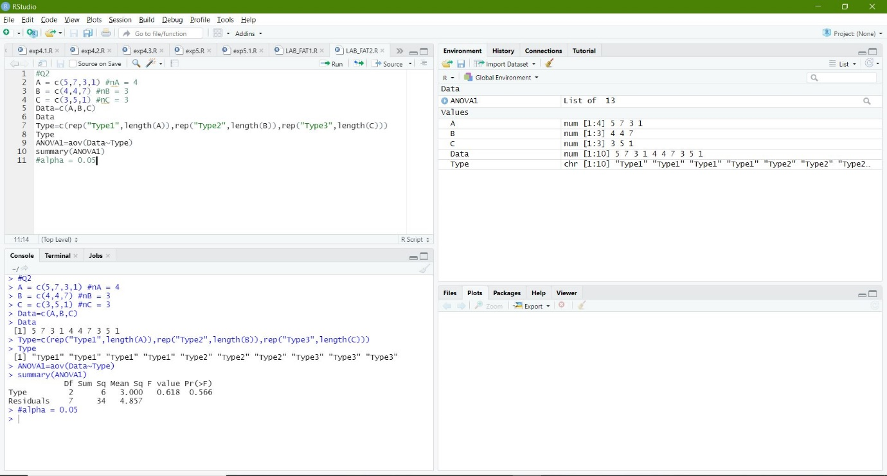

**Global Variables:**

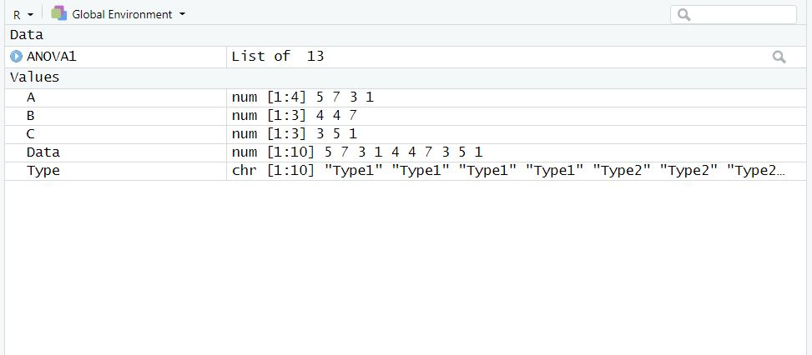

**Q3) Viva-Voce/Quiz: ANSWERS:**

1) t = M*(matrix(c(),nrow=3,ncol=2,byrow=TRUE)

2) Mean = sum(seq(25,82,1))/(82-25)

3) Option (b) - 2

4) Option (b) – not be extracted

5) Option (c) – storage.mode

__________________________________________________________________________________